 | 1. | Three infinite sheets of charge are parallel to each other, as is shown in Fig. 5 below. The sheet on the left has a uniform surface charge density +σ, the one in the middle a uniform surface charge density -σ and the one on the right a uniform surface charge density of +σ. Find the electric field at (a) P₁, (b) P₂, (c) P₃, and (d) P₄.  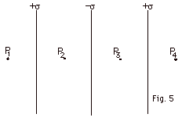
2. | Charge Q is distributed uniformly throughout a sphere of radius R (Fig. 6 below). Find the electric field for (a) r ≤ R, (b) r ≥ R. (c) Sketch a graph of E as a function of r.  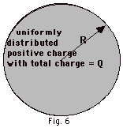

3. | A conducting sphere of charge +Q and radius a, is concentric with a conducting, spherical shell that has a net charge of 0. The shell has inner radius b and outer radius c. (a) Where are the charges? Find the electric field for (b) r ≤ a, (c) a ≤ r ≤ b, (d) b ≤ r ≤ c and (e) r ≥ c.

4. | A point charge q_{i} = 8.85 µC is at the center of two concentric conducting shells as shown in Fig. 7 below. The net charge on the inner shell is -17.70 µC and the net charge on the outer shell is +8.85 µC. Find (a) the inner charge q_{a} and the outer charge q_{b} on the inner shell and (b) the inner charge q_{c} and the outer charge q_{d} on the outer shell. (c) Sketch a graph of the net flux through a Gaussian sphere centered on the point charge as a function of the distance r from the point charge.  